Introduction To JAVA
What is JAVA?
Java is simple, high performance, object-oriented, robust, secure, multi-threaded, and platform independent programming language to develop software that can be used for gaming, web, business, desktop, database, and other applications.
History Of Java
- Java was developed at Sun Microsystems in 1991.
The development team was led by James Gosling,Mike Sheridan, and Patrick Naughton.
The project was initially called "The Green Project".
Sun Microsystems was later acquired by Oracle Corporation in 2010.
- The design goal of Java is WORA(Write Once Run/Execute Anywhere) it means write a program once and then run this program on multiple operating systems.
- The first publicly available version of Java (Java 1.0) was released in 1995 and the current of version of Java is Java SE11 released on September, 25th 2018
Important Features Of Java
Simple
- It does not use header files.
- Eliminated the use of pointer and operator overloading.
- Java is easy to learn and familiar because java syntax is just like c++.
- There is a provision of Automatic Garbage Collection, in which there is no need to remove the unreferenced objects explicitly.

Compiled and Interpreted
- Usually, a computer language can be either compiled or interpreted. Java integrates the power of Compiled Languages with the flexibility of Interpreted Languages.
- Java compiler (javac) compiles the java source code into the bytecode.
- Java Virtual Machine (JVM) then executes this bytecode which is executable on many operating systems and is portable.
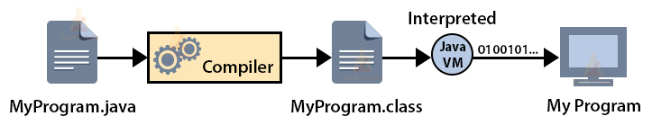

Platform Independent
- Platform-independent means a program compiled on one machine can be executed on any machine in the world without any change. Java achieves platform independence by using the concept of the BYTE code.
- The Java compiler never converts the source code to machine code like that of the C/C++ compiler. Instead, it converts the source code into an intermediate code called the byte code and this byte code is further translated to machine-dependent form by another layer of software called JVM (Java Virtual Machine).
- Therefore, JVM can execute bytecode on any platform or OS on which it is present, regardless of the fact that on which machine the bytecode was generated.
- This is where the “Write Once, run anywhere” (WORA) slogan for Java comes in, which means that we can develop applications on one environment (OS) and run on any other environment without doing any modification in the code.

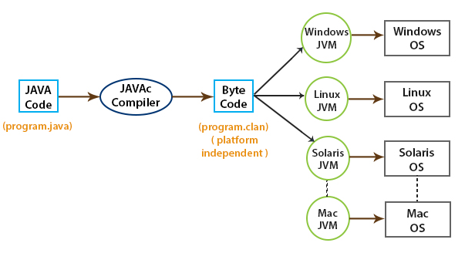
Portable
- You can run Java bytecode on any hardware that has a compliant JVM which can convert the bytecode according to that particular machine.
- In Java, the size of the primitive data types is machine-independent, which were dependent in the case of C/C++. So, these provisions make Java programs portable among different platforms such as Windows, Unix, Solaris, and Mac.
- Moreover, any changes and updates made in Operating Systems, Processors and System resources will not enforce any changes in Java programs.

Object Oriented Programming Language
- Object oriented programming is a way of organizing programs as collection of objects, each of object represents an instance of a class.
- Java programs also organizing collection of classes and objects so Java is called as object oriented programming language
Robust
Robust means inbuilt capabilities to handle errors/exceptions.
Java is robust because of following
- Built-in Exception handling.
- Strong type checking i.e. all data must be declared an explicit type.
- Automatic garbage collection.
- First checks the reliability of the code before Execution etc.

Secure
- Java programs run within the JVM which protects from unauthorized access to system resources.
- That’s why several security flaws like stack corruption or buffer overflow is impossible to exploit in Java

Multithreading
Java supports multithreading. Multithreading is a feature that allows concurrent execution of two or more parts of a program for maximum utilization of CPU.
Distributed
- This feature in Java gives the advantage of distributed programming, which is very helpful when we develop large projects. Java helps us to achieve this by providing the concept of RMI (Remote Method Invocation) and EJB (Enterprise JavaBeans).
- In Java, we can split a program into many parts and store these parts on different computers. A Java programmer sitting on a machine can access another program running on the other machine.
- Java comes with an extensive library of classes for interacting, using TCP/IP protocols such as HTTP and FTP, which makes creating network connections much easier than in C/C++.
- It also enables multiple programmers at many locations to work together on a single project.

Architectural Neutral
Architectural neutral means that the program written on one platform is independent of other platforms and can run on any other platform without recompiling them.
Byte-code is not dependent on any machine architecture and Java Virtual Machine (JVM) can easily translate bytecode into a machine-specific code.
Dynamic
The process of allocating the memory space to the input of the program at a run-time is known as dynamic memory allocation. In Java memory allocation happened at run-time with the help of 'new' operator. So Java is dynamic
High performance
- Java provides high performance with the use of “JIT – Just In Time compiler”, in which the compiler compiles the code on-demand basis, that is, it compiles only that method which is being called. This saves time and makes it more efficient.
- Java architecture is also designed in such a way that it reduces overheads during runtime. The inclusion of multithreading enhances the overall execution speed of Java programs.
- Bytecodes generated by the Java compiler are highly optimized, so Java Virtual Machine can execute them much faster.

Components Of Java Software
Java Development Kit (JDK)
- Java Development Kit contains two parts. One part contains the utilities like javac, debugger and some jar files which helps in compiling the source code (.java files) into byte code (.class files) and debug the programs.
- The other part is the JRE, which contains the utilities like java which help in running/executing the byte code. If we want to write programs and run them, then we need the JDK installed.
Java Run-time Environment (JRE)
- Java Run-time Environment helps in running the programs.
- JRE contains the JVM, the java classes/packages and the run-time libraries.
- If we do not want to write programs, but only execute the programs written by others, then JRE alone will be sufficient.

Java Virtual Machine (JVM)
- Java Virtual Machine is important part of the JRE, which actually runs the programs (.class files), it uses the java class libraries and the run-time libraries to execute those programs.
- Every operating system(OS) or platform will have a different JVM.

Just In Time Compiler (JIT)
JIT is a module inside the JVM which helps in compiling certain parts of byte code into the machine code for higher performance.
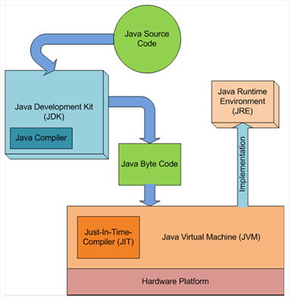

Editions Of Java Software
JavaSE (Java Standard/Software Edition)
- JavaSE is mainly used to create applications for Desktop environment.
- It consist all the basics of Java the language, variables, primitive data types, Arrays, Streams, Strings Java Database Connectivity(JDBC) and much more.
JavaEE(Java Enterprise Edition)
- The enterprise edition of Java has a much larger usage of Java, like development of web services, networking, server side scripting and other various web based applications.
- JavaEE uses many components of JavaSE, as well as, has many new features of it’s own like Servlets, JavaBeans, Java Message Services etc,.

JavaME (Java Micro/Mobile Edition)
This version of Java is mainly concentrated for the applications running on embedded systems, mobiles wireless devices, set top boxes etc.
Old Nokia phones, which used Symbian OS, used this technology.

JavaFX
JavaFX is an open source, next generation client application platform for desktop, mobile and embedded systems built on Java. It is a collaborative effort by many individuals and companies with the goal of producing a modern, efficient, and fully featured toolkit for developing rich client applications.

Jit Compiler
A Just-In-Time (JIT) compiler is a program that translates bytecode into machine code while a program is running. This improves the performance of applications by making them run faster.
How it works
- A JIT compiler is part of the runtime environment.
- When a program starts, the JIT compiler compiles bytecode into machine code.
- Once a method has been compiled, the program can call the compiled code instead of interpreting it.
Benefits
- JIT compilers can improve runtime performance.
- They can save storage space.
- They can speed up application and system updates.
Use cases
- JIT compilers are used in Java Virtual Machine (JVM).
- They are also used in Common Language Runtime (CLR) in C#.

Parts of System.out.println()
The statement can be broken into 3 parts which can be understood separately:
- System: It is a final class defined in the java.lang package.

- out: This is an instance of PrintStream type, which is a public and static member field of the System class.

- println(): As all instances of the PrintStream class have a public method println(), we can invoke the same on out as well. This is an upgraded version of print(). It prints any argument passed to it and adds a new line to the output. We can assume that System.out represents the Standard Output Stream.

public static void main(String args())

public:-it is access modifier then only jvm can accessible main() method

static:- non access modifier in java main() executed before the creation of an object

void- in return type in java with no argument.
In javamain() method start the execution of a program not to get the return value. So main() method doest have return type

****vvi
Explain why main() declared as ststic?
Ans- if main() method is instance method to access that method object is required but in java object created after execution of main() method.
It means main() method execution does not depend an object of class.
If main() method is static then that method execution not depends on class name
To execute main() method.
JVM internally use the name of the class that’s why class name must with (dot).java file nmae

